
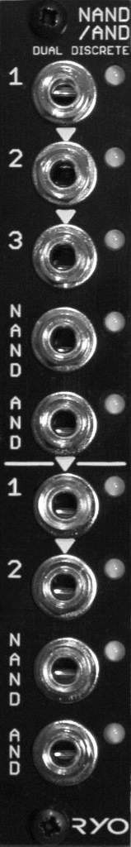

LjunggrenAudio RYO NAND/AND
Discrete Resistor-Transistor Boolean Logic in 4hp

Quickstart – what is the NAND/AND and how do I get going?

The circuitries of the RYO logic gate modules are directly modelled after the very earliest form of digital logic gate designs using resistor-transistor-logic (RTL) pioneered in the 1950s and used in computing equipment throughout the 50s and 60s. For instance, the Apollo Guidance Computer used the same type of 3-input NOR gate design now found in the RYO NOR/OR module, although in vastly greater numbers.

Installation

To begin installation, please make sure that:
- you have a standard pinout eurorack bus board
- you have +12V and -12V power rails on that bus board [no +5V supply is required]
- the power rails are not overloaded

!!!Before installing this module disconnect the power from your system!!!

- Double check the polarity of the ribbon cable - The red stripe should be aligned with the -12V rail, on both the module and on the bus board

[we use shrouded headers but it's still possible a cable has been assembled with the stripe on the wrong side of the shroud so always double check!].

Also make sure when using busboards without shrouded headers that the pins aren't transposed a row vertically or horizontally – all pins should insert into holes on the cable.

Although we use both PTC fuses and schottky diodes to provide reverse polarity and excess current protection, we do not take any responsibility for damages caused by wrong power supply connection!

After you have connected everything, double checked it and ensured your case is closed such that no power lines can be touched by your hand or any stray cables drop into holes, turn on your system and test the module

The NAND/AND is a relatively low skill-level project, it is a low part count, twin-PCB build that only requires fairly basic experience in PCB soldering and module assembly:

The RTL circuit design gives the modules some interesting quirks thanks to the transistors threshold windows when playing around with different amplitudes, waveforms and frequency rates of the incoming signals, making it fun and useful to explore beyond typical logic gating duties, for example as an audio waveshaper/distortion.

The NAND/AND module can be patched as:
- two NOT gates,
- one NOT gate and one 2- or 3-input NAND/AND gate,
- one 2-input NAND/AND gate and one 2- or 3-input NAND/AND gate, or,
- one 4-input NAND/AND gate.

Gate one has three inputs, the second has two. The inputs on gate one is normalled in a 1>2>3 fashion for efficient cable and time-saving patching. The inputs on gate two has also been normalled 1>2, with the AND out from gate one in turn being normalled to input 1 on gate two.

Dimensions
Height: 3U [128.5mm],
Width: 4HP [20mm],
Depth: 45mm (with power cable attached)

Weight: ???g

Current consumption
+12V rail max 28mA (@10V input signal)*
-12V rail 0V
+5V rail no +5V supply required

*(14mA @ 5V input signal)

Basic specifications
total frequency controllable range dc to 50kHz
max input/output audio signal 20Vpp
CV input range n/a

Max gain n/a

Nominal impedances
Audio signal input: 100k ohm
Audio Signal output: 1k ohm
CV input: n/a

Patch ideas:

basic logic uses?:

below i've included some inspiring words blah blah; and, as ever, experiment – RYO modules are designed with all necessary protection and fail-safes so you can just start plugging in patch cables and see what happens!

Audio mangler;
can take any audio in?

Weird clock divisions for percussive rhythms?;

Insert patch ideas here;
lorem ipsum got no more patch ideas. lorem ipsum got no more patch ideas. Lorem ipsum got no more patch ideas. lorem ipsum got no more patch ideas. lorem Ipsum got no more patch ideas. lorem ipsum got no more patch ideas. lorem ipsum got no more patch ideas. lorem ipsum got no more patch ideas. lorem ipsum got no more patch ideas. lorem ipsum got no more patch ideas. lorem ipsum got no more patch ideas. lorem ipsum got no more patch ideas. lorem ipsum got no more patch ideas. lorem ipsum got no more patch ideas.

